Practical S Part II

What is a Join?

A JOIN combines records from two or more tables using a related column.

Types of Joins:

1. INNER JOIN Returns only matching records.
2. LEFT JOIN Returns all records from the left table and matching records from the right table.
3. RIGHT JOIN Returns all records from the right table and matching records from the left table.
4. FULL OUTER JOIN Returns all records from both tables (not available in MySQL).
5. CROSS JOIN Returns the Cartesian product of both tables.
6. SELF JOIN Joins a table to itself.
7. Customer Table

|  |  |  |
| --- | --- | --- |
| **Column** | Data Type | Constraints |
| customer_id | NUMBER (PK) | PRIMARY KEY, AUTO-INCREMENT |
| name | VARCHAR2(100) | NOT NULL |
| email | VARCHAR2(100) | UNIQUE |
| phone | VARCHAR2(15) | NOT NULL |
| address | VARCHAR2(255) | NULLABLE |

1. Product Table

|  |  |  |
| --- | --- | --- |
| Column | Data Type | Constraints |
| product_id | NUMBER (PK) | PRIMARY KEY |
| name | VARCHAR2(100) | NOT NULL |
| category | VARCHAR2(50) | NOT NULL |
| price | DECIMAL(10,2) | NOT NULL |
| stock_quantity | INT | NOT NULL |

1. Order_DetaiIs Table

|  |  |  |
| --- | --- | --- |
| Column | Data Type | Constraints |
| order_id | NUMBER (PK) | PRIMARY KEY |
| customer_id | NUMBER (FK) | FOREIGN KEY REFERENCES  Customer(customer_id) |
| order_date | DATE | NOT NULL |
| totaI_amount | DECIMAL(10,2) | NOT NULL |

1. Order_ltem Table

|  |  |  |
| --- | --- | --- |
| Column | Data Type | Constraints |
| order_id | NUMBER (FK) | FOREIGN KEY REFERENCES  Order_DetaiIs(order_id) |
| product_id | NUMBER (FK) | FOREIGN KEY REFERENCES  Product(product_id) |
| quantity | INT | NOT NULL |
| subtotal | DECIMAL(10,2) | NOT NULL |

1. Employee Table

|  |  |  |
| --- | --- | --- |
| Column | Data Type | Constraints |

|  |  |  |
| --- | --- | --- |
| empIoyee_id | NUMBER (PK) | PRIMARY KEY |
| name | VARCHAR2(100) | NOT NULL |
| role | VARCHAR2(50) | NOT NULL |
| salary | DECIMAL(10,2) | NOT NULL |
| hire_date | DATE | NOT NULL |

Examples of Joins

INNER JOIN: Get order details with customer names

SELECT o . o rde ra1d , c . name , o . o rde r date , o . t ota 1 amount FROM 0 rde r Det a11 s o

INNER JOIN Cus tome r c ON o . cust ome ra1d = c . cus tome ra1d ;

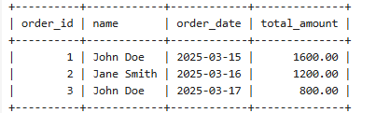

INNER JOIN: Retrieve product names and their order quantities SELECT p.name, oi.quantity

FROM 0 rde r Item o1

INNER JOIN Product p ON o:I . p roduct :td = p . p roduct :td ;

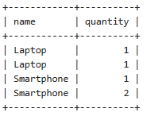

LEFT JOIN: Get all customers and their orders (including those who never ordered)

SELECT c.name, o.order id, o.total amount FROM CusI ome r c

LEFT JOIN 0 rde r Det a:its o ON c . cusI ome re:Id = o . cus tome re:Id ;

LEFT JOIN: Retrieve all products and their order details (including those not ordered yet)

SELECT p.name, oi.quantity FROM Product p

LEFT JOIN Order Item oi ON p.product id = oi.product id;

RIGHT JOIN: Get all orders with or without employee assigned

SELECT o.order id, e.name AS employee name FROM Order Details o

RIGHT JOIN Employee e ON o.customer_id = e.employee id;

RIGHT JOIN: Retrieve employees who processed orders

SELECT e . name, o . o rde re:Id

# FROM Emp1oyee e

RIGHT JOIN 0 rde r Det a11 s o 0N e . emp1oyee 1d = o . custome ra1d ;

FULL OUTER JOIN: Get all customers and orders (Oracle SQL only) SELECT c . name, o . o rde re:Id , o . t ot a1 amount

FROM Cus t ome r c

FULL OUTER JOIN 0 rde r Det a11 s o ON c . cus t ome ra1d = o . cus t ome ra1d ;

CROSS JOIN: Show all possible employee-product assignments

SELECT e.name AS employee, p.name AS product

# FROM Emp loyee e

CROSS JOIN Product p ;

SELF JOIN: Find employees earning more than their colleagues

SELECT e1.name AS Employee, e2.name AS Colleague, e1.salary

# FROM Emp1oyee e1

JOIN Emp1oyee e2 ON e1 . sa1ary > e2 . sa1ary ;

SELF JOIN: Find employees working under the same manager

SELECT e1.name AS Employee, e2.name AS Manager

# FROM Emp loyee e1

JOIN Emp loyee e2 ON e1 . role = ' Cash1e r ' AND e2. role =

' Manage r ' ;

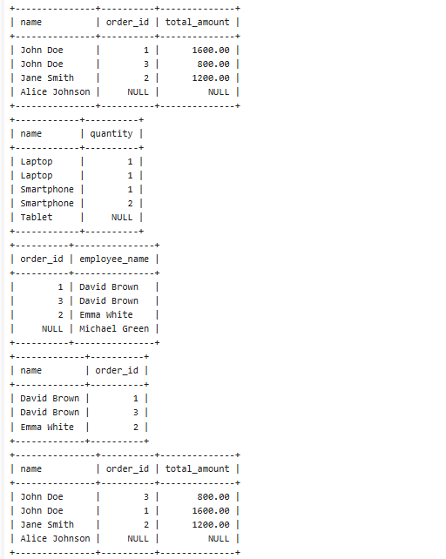

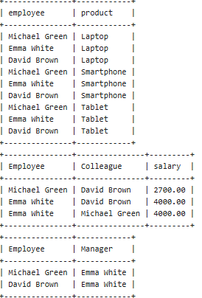

Joins Tasks

1. Retrieve customer names along with their orders.
2. Show product names and their order quantities.
3. List all customers and their orders (including those who never ordered).
4. Retrieve all products and their order details (including those not ordered yet).
5. Find employees who have processed orders.
6. 